## Simple CALCULATOR

Create the following Web page with the heading 'Calculator' and provided images.  

Sample Output Screen:

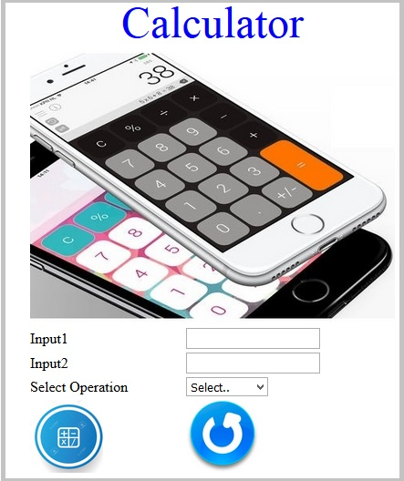

The web page should contain following input elements and apply the specified Constraints:

|  |  |  |
| --- | --- | --- |
| Label Name | Element Name | Constraints |
|  | headerimg | An image for header must be included using img tag |
| Input1 | input1 | This element is to get the first input. Type should be 'number' |
| Input2 | input2 | This element is to get the second input. Type should be 'number' |
| Select Operation | operation | A drop down list contains the following values: **Select..**, **ADD, SUBTRACT, MULTIPLY and DIVIDE.**  **Set these values as its option tag text and option tag's 'value' attributes** |
|  | submit | An image for submit must be included using img tag |
|  | reset | An image for reset must be included using img tag |

Consider the images are in the current folder and

* Use "calculator.jpg" as a header image. Include it using img tag.
* Use "calc.jpg" for submit element and "reset.jpg" for reset element.

**Apply following styles to the attributes**: Do not use CSS .

1. The heading should be displayed as "Calculator" using h1 tag. (case-sensitive)
2. The height and width of the images with the name "submit" and "reset" should be '80'.
3. The height and width of the calculator image with the name "headerimg" should be '300' and '400'.

Books Form

Bookzone Library is a startup firm that has a good collection of books.  They want the customer and book details to be submitted in a web page in order to issue books. They want to create a static web page for the library in order to get the customer details and the details of books to be issued.

Create a web page bookform.html that lets the form to allow auto completion of values. It needs to accept the Customer Info such as Name, Telephone and Email address and the Books details from a datalist and the quantity of books. It should display "You have successfully submitted the Book Form" in an alert box when the details are submitted, and it should remain in the same page.

The initial web page should look like as follows

**Figure 1**

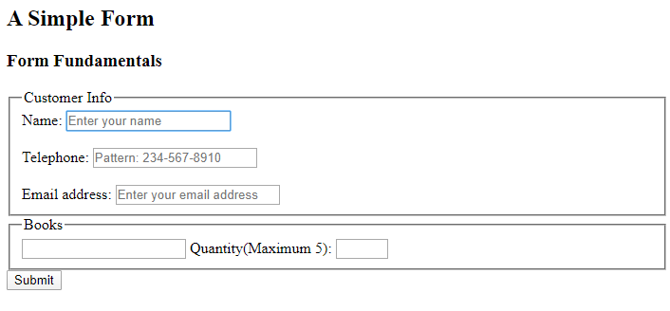

The outcome web page should look as follows

**Figure 2**  
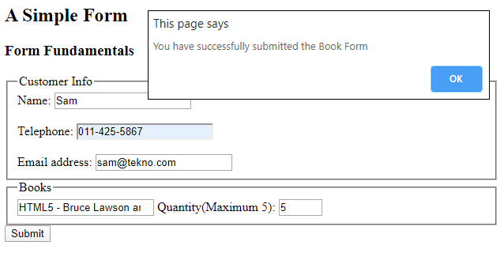  
  
  
The requirements are as follows,

|  |  |  |
| --- | --- | --- |
| **Req. #** | **Req. Name** | **Req. Description** |
| 1 | Designing a Web page "bookform" which also allows the form to autocomplete the values with the specified fields. Use the respective feature for it. | |  |  |  | | --- | --- | --- | | Label Name | Component Name | Description | |  | Customer Info  Books | In Figure 1 above, shows that two field sets are used to create the main structure of the form. The task is to create the field sets with the names Customer Info and Books respectively | | Name | cusname | The name input field you create should have autofocus, should set the placeholder text as "Enter your name", set field type as 'text', and it is a mandatory field | | Telephone | telephone | The telephone input field type should be 'tel', placeholder text should be "Pattern: 234-567-8910", (The telephone number should have three numbers, followed by a hyphen, three numbers, a hyphen and four numbers). Use pattern to restrict the entry. It is a mandatory field. | | Email address | mail | The mail field should have placeholder text as "Enter your email address". It is a mandatory field**.** Element name should be 'mail' and type should be 'email'. A valid email example is abc@sample.com | | Quantity (Maximum 5) | quantity | The quantity field should have a minimum value of 1 and a maximum value of 5.  The type should be 'number'. | |  | book | 'book' is an input list element with the   'list' attribute's value as 'books'.  An auto-complete feature should be available to the user. Name of the auto-complete feature is "books" and it should be available with the following options:  HTML5 - Bruce Lawson and Remy Sharp  HTML5 - Up and Running - Mark Pilgrim  Head First HTML5 Programming - Eric Freeman Mastering HTML, CSS and JavaScript - Laura Lemay | |  | submit | The submit input field type should be 'submit' and name attribute is submit.   On submission of the form, it should display an alert box with a message "You have successfully submitted the Book Form" as shown in Figure 2 above |    NOTE: Use the Label Name and Component Names as given  All validations should be based on HTML 5 (Do not use Javascript). |

CSS

Learning Material Styling

Greenwood Training Company wants to present their Learning material Online. They also want to apply Styling to their Learning content.

**Concepts covered**: **CSS3 Selectors - Element Type Selector, Id Selectors, Class Selectors and Grouping Selectors**

The following is the screenshot of Learning Material Styling **– You can use your own styling**

  
**Use the CSS Selectors with the given Properties and Values.**

Provide the details as given in the table below.

|  |  |
| --- | --- |
| **CSS Selectors** | **Properties And Values** |
| body | ·         background color should be “**#00FFFF**”  ·         font family should be **“Arial”**  ·         font size should be**“12px”** |
| h1 | ·         font size should be **“2.5em”** |
| dd | ·         font size should be **“1.5em”** |
| p[title] | ·         color should be **“#FF0000”**  ·         font size should be **“1.7em”**  ·         line height should be **“1.5”** |
| reasons | ·         color should be **“#FF0F70”**  ·         font should be displayed in **“bold”**  ·         line height should be **“1.5”**  ·         font size should be **“1.5em”** |
| description01 | ·         font style should be **“italic”**  ·         color should be **“#F500FF”** |
| description07 | ·         font style should be **“italic”**  ·         color should be **“#FF4500”**  ·         font should be displayed in **“bold”** |
| em | ·         color should be **“#FF0000”**  ·         font should be displayed in **“bold”** |

## Trainer Feedback Rating Chart

Learning Partner Training Company wants to send Trainer's Feedback every month to the trainers. They also want to apply Styling to the Trainer Feedback Rating Chart.

**Concept covered**: **CSS3 Styling - CSS Color, CSS Background, CSS Fonts and CSS Text**

The following is the screenshot of the Trainer Feedback Rating Chart

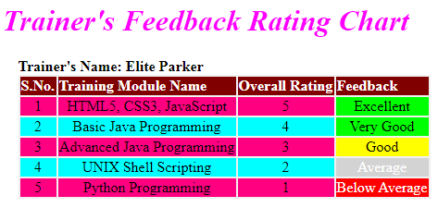

**Use the CSS Selectors with the given Properties and Values.**

Provide the details as given in the table below.

|  |  |
| --- | --- |
| **CSS Selectors** | **Properties And Values** |
| h1 | -         text should be aligned to the **"center"** of the page  -         color should be **"#FF00FF"**  -         font style should be**"italic"** |
| table | -         text should be aligned to the **"left"**of the page  -         margin left should be **"35%"**  -         background color should be **"#F0F0F0"** |
| td | -         text should be aligned to the **"center"** of the page |
| caption | -         text should be aligned to the **"left"** of the page  -         font should be displayed in **"bold"** |

Set background color of component with class tr1 as : #ff0080  
Set background color of component with class theader as : #800000  
Set background color of component with id ex1 and vg1 as : #00ff00  
Set background color of component with id go1 as : #ffff00  
Set background color of component with id av1 as : #d3d3d3  
Set color of component with id av1 as : #ffffff  
Set background color of component with id bal as : #ff0000  
Set color of component with id bal as : #ffffff

Book A Show - Online Ticket Booking

"BOOK A SHOW" is an online movie ticket system to book tickets for current and upcoming movie releases across the city in India. The user can select the movie and preferred circle and the ticket details while booking the ticket.

Create a web page ticket.html to accommodate details that will be entered by the user such as name, movie name, circle (Silver, Gold or Platinum), phone number, showdate, number of adults and children. On submission of the form, an alert box should be displayed with a message "Booking Successful" and it needs to remain on the same page.

The web page should look like

**Sample Webpage:**

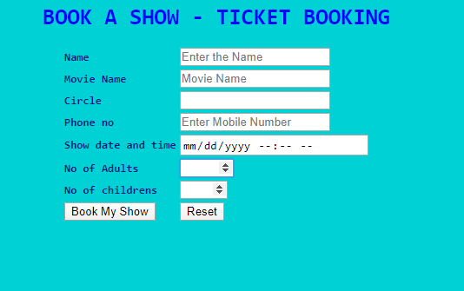

The outcome webpage should look as

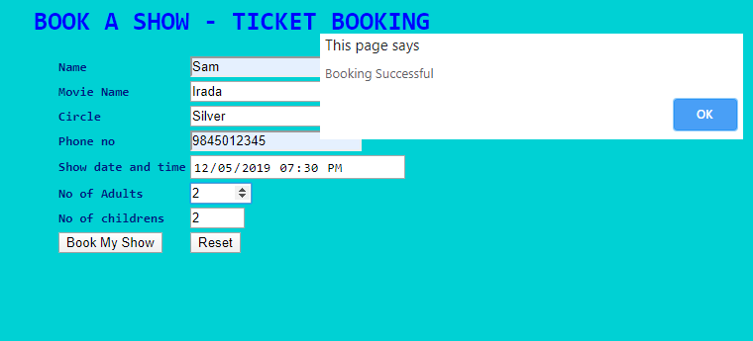

The requirements are as follows,

|  |  |  |
| --- | --- | --- |
| **Req. #** | **Req. Name** | **Req. Description** |
| 1 | Design a Web page "ticket.html" with the specified fields. | |  |  |  | | --- | --- | --- | | Label Name | Component Name | Description | | Name | name | To enter the name. It is a mandatory field and should be validated. Should not allow any special characters other than space. | | Movie Name | moviename | An auto-complete feature should be available to the user for the following options.  Irada, Rangoon, Logan, Fist Fight.  (Name of the auto-complete feature should be "movies") | | Circle | circle | An auto-complete feature should be available to the user for the following options.  Silver, Gold, Platinum.  (Name of the auto-complete feature should be "circles") | | Phone no | phone | To enter the phone number.  Should validate for numeric digits. Should contain 10 digits. | | Show date and time | showdate | Date time picker control to choose the date and time of the show. Use the input type as datetime-local | | No of Adults | tickets | Choose the number of adults. An input of type number that can have a minimum value of 1 and maximum value of 10. | | No of childrens | children | Choose the number of children. An input of type number that can have a minimum value of 1 and maximum value of 5. | |  | submit | An input type of submit that has a value as Book My Show. On submission of the form, an alert box should be displayed with a message "Booking Successful" and it needs to remain on the same page | |  | reset | An input type of reset that has a value as Reset. On clicking this button, all fields should be reset |   **NOTE: Use the Label Name and Component Names as given**  **All validations should be based on HTML 5 (Do not use Javascript). All the fields are mandatory** |
| 2 | Apply the mentioned styles using CSS to the components. | 1.      Use a table element to render the form elements. The table element will have a style of font-family as monospace and font-weight as bold  2.      The h1 element should have color as #0000FF and font-family as monospace and text needs to be center aligned  3.      The body background color should be #00CED1.  4.      The text color should be #0C1584.  **Note: (Do not use Inline CSS)** |

**Note: Make sure all tags and attributes are in lower case**

Palindrome Check

Techno Talent Finishing School has decided a contest for their students to find if the given input string is a palindrome or not.  The logic must check whether a word or a sentence is palindrome or not irrespective of case and spaces.

Design a HTML file named palin.html that has an input text box and a button. The input text box named palin accepts the word / sentence and on clicking the button named palinbtn, the output message is alerted as shown in Output Webpage below, and it should remain in the same page.

The initial web page should look like as follows,

**Sample Webpage**

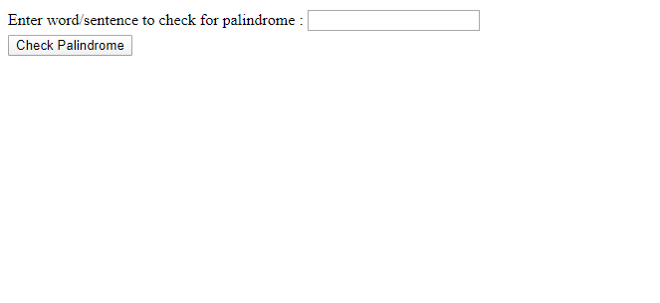

**The outcome webpage should look as follows,**

**Output Webpage**

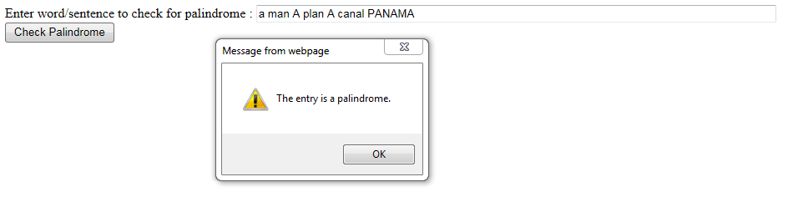

**Note:**Remove all white spaces from the input given and check for palindrome for the same input ignoring case.

|  |  |  |
| --- | --- | --- |
| **Req. #** | **Req. Name** | **Req. Description** |
| 1 | Designing a Web page "palin" with the specified fields. | |  |  |  | | --- | --- | --- | | Label Name | Component Name | Description | | Enter word/sentence to check for palindrome: | palin | The input text box named palin accepts the word / sentence | |  | palinbtn | An input type of submit and has the name palinbtn. On click, it displays an alert box to show the output message of whether the given string is a palindrome or not. |   **NOTE: Use the Label Name and Component Names as given.**  **All validations should be based on HTML 5 (Do not use Javascript).** |
| 2 | Use JavaScript for checking palindrome | A JavaScript function must be written to check whether a word or a sentence is palindrome or not irrespective of case and spaces, and appropriate alert message has to be displayed on click of a button named "palinbtn".  Alert message should be either **"The entry is a palindrome."**or**"The entry is not a palindrome."** as given in the sample output page.  A few examples of output alert messages are shown below:  LiRiL - The entry is a palindrome.  Apple - The entry is not a palindrome.  Was it a cat I saw - The entry is a palindrome. |

**Note: Make sure all tags and attributes are in lower case.**  
**In Javascript, please do not use "let". Instead, use "var".**